Model Evaluation
The model with the lowest validation loss included depth_bin, season, diel, and salinity as features (model D in Table 1). Starting from a null model with a loss of 1.740 (geometric mean probability [gmp] of 17.6%), adding depth_bin (model A) reduced the loss to 1.457 (gmp 23.3%). Including season (model B) brought it to 1.368 (gmp 25.5%), and adding the diel features (model C) lowered it again to 1.352 (gmp 25.9%). With salinity included (model D), the final validation loss reached 1.340 (gmp 26.2%).
Both the data and model reflected a strong skew in depth distribution. Nearly half (46.4%) of all samples were found in the 0–25 m depth bin, and 85.6% were within 100 m of the surface (Table 2). When depth_bin was added to the null model, the loss dropped by 0.283, consistent with this distributional skew.
Depth occupancy varied seasonally in both the validation data and model predictions (Figure 1). The proportion of samples deeper than 25 m reached its lowest point in June, at approximately 32% in the validation data and 34% in the predictions. This proportion rose steadily through the fall, reaching 70% and 74% by November, and remained elevated through the winter months (60–75%) before beginning to drop again in early spring.
Diel variation in depth occupancy also appeared in both predictions and actuals, with notable seasonal shifts in both magnitude and direction (Figure 2). In August, the proportion of samples deeper than 25 m rose from ~27% at night to ~72% during the day — a diel swing of 45%. This difference declined to ~35% by October and ~17% by January. In February, the pattern reversed, with more samples deeper than 25 m at night. While model predictions captured this pattern, large differences remained between the validation and training data, including a 25% discrepancy in May.
Model predictions showed a consistent shift toward low salinity, near-surface waters in all months except August and September (Figure 3). This shift was largest between November and February, peaking in February with a difference of nearly 30%. Between March and June, the difference ranged from 6% to 14%. In August and September, however, model predictions instead showed a shift toward the surface in higher salinity waters, with an average difference of approximately 7%.
However, the effect of salinity on loss varied by month and differed between training and validation sets (Figure 4). From December to February, the two sets showed opposing trends. In December and January, the training data showed reductions in loss (-0.03 and -0.05), while the validation data showed slight increases (+0.02 and +0.05). In February, the training loss remained unchanged, but the validation loss dropped substantially by 0.14. During the remaining months, changes in loss were smaller (up to 0.03), yet discrepancies in magnitude between the validation and training sets persisted even when the direction of change was aligned.

Assessing Likelihood of Occupancy Near the Seafloor
Likelihood near the seafloor was assessed to understand the model’s implications for Chinook salmon occupancy in the portion of the water column occupied by trawl gear. Specifically we are interested in when these likelihoods are minimized.
The minimum predicted likelihood of occupancy in the deepest bin varied across space and season (Figure 5). In February, the lowest likelihood values occurred along the shelf edge, where they dropped below 1%. Across the shelf, these values varied considerably, with neighboring cells often differing by 10% or more. In August, minimum likelihoods remained low (<1%) except for several persistent hotspots that were shared with February. One such hotspot, located just west of Kodiak, showed a minimum likelihood of 15%, roughly three times higher than surrounding areas.
In a specific H3 cell near Chignik (Figure 6), both depth occupancy and diel variation changed meaningfully over the year. During winter, the deepest occupancy levels were observed, with ~50% of samples deeper than 25 m. At the same time, diel variability decreased, from nearly 20% between day and night in the 100 m depth bin in November to 10% in January. Beginning in March, occupancy shifted shallower, with only ~30% of samples deeper than 25 m by May. Diel variation increased again in July and August, peaking at ~45% in September. As a result, while average occupancy was shallowest in spring, the highest occupancy in the 25 m bin occurred at night during late summer.
At a broader regional scale, the time of day that minimized likelihood of occupancy in the deepest bin also varied across space and season (Figure 7). In August, this minimum occurred at night in nearly all locations, with only one exception. In contrast, February showed much more spatial variation. That month few cells had nighttime minima, except near the edge of the continental shelf. Instead, the lowest likelihoods were more commonly observed during the day or around dawn or dusk.

Model | Features | Loss Train | Loss Validation | Geometric Mean Probability  Validation
Null |  | 1.835 | 1.740 | 17.6%
A | depth_bin | 1.412 | 1.457 | 23.3%
B | A + season | 1.330 | 1.368 | 25.5%
C | B + diel | 1.313 | 1.352 | 25.9%
D | C + salinity | 1.308 | 1.340 | 26.2%
Table 1: Model Improvements over Features. Deep learning was used to train on and then predict the depth bins occupied by individual Chinook salmon at 15 minute intervals in the Gulf of Alaska and Eastern Bering Sea. The objective of the training was to optimize the overall likelihood of the data given the predictions by minimizing a categorical cross entropy loss function. Beginning with a null model - predicting equal probabilities across all depth bins – each new model (A – D) demonstrates the improvement in loss each new feature brings to our selected model D. Training loss represents the loss over the data the model saw during training, validation loss is the loss over a holdout set. Geometric mean probability is the geometric mean of the probability of the data given the model.

Depth Bin | Proportion of Samples
[0, 25] | 46.4%
(25, 50] | 16.6%
(50, 75] | 13.0%
(75, 100] | 9.6%
(100, 150] | 10.1%
(150, 200] | 3.1%
(200, 250] | 0.6%
(250, 300] | 0.3%
(300, 400] | 0.1%
(400, 500] | <0.1%
Table 2: Depth Skew. Over observations of depth occupancy across tagged Chinook salmon in the Gulf of Alaska and Eastern Bering Sea, the proportion of samples in each of our depth bins (units in meters).

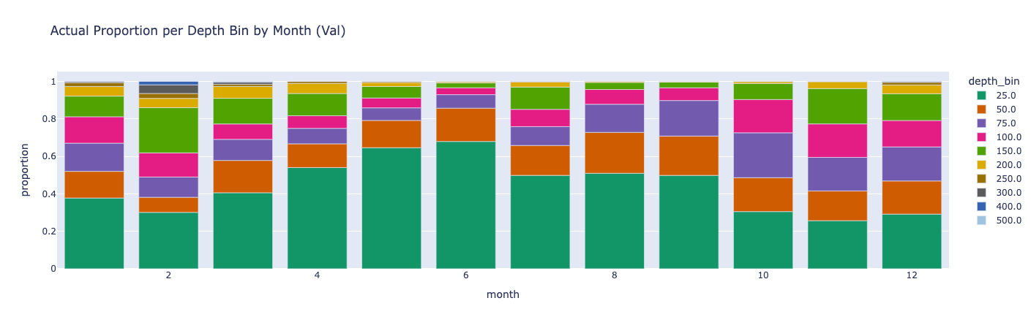
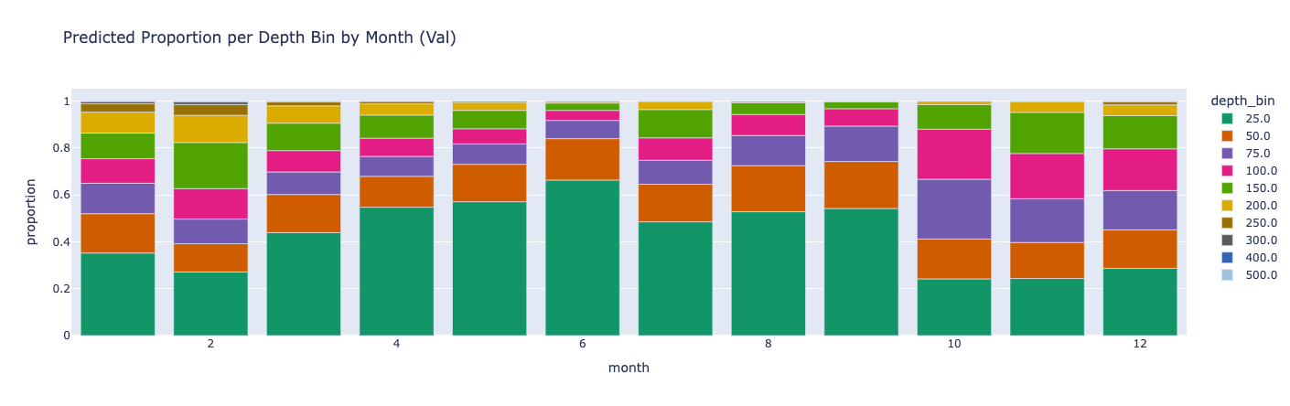
Figure 1: Seasonal Shifts in Depth Occupancy. (Top) Using observations of depth at 15-minute intervals from individual Chinook salmon (GOA and EBS), the proportions of samples in each depth bin across all months. (Bottom) For those same samples, mean predicted probability of the occupied depth from a deep learning model binned across all months.
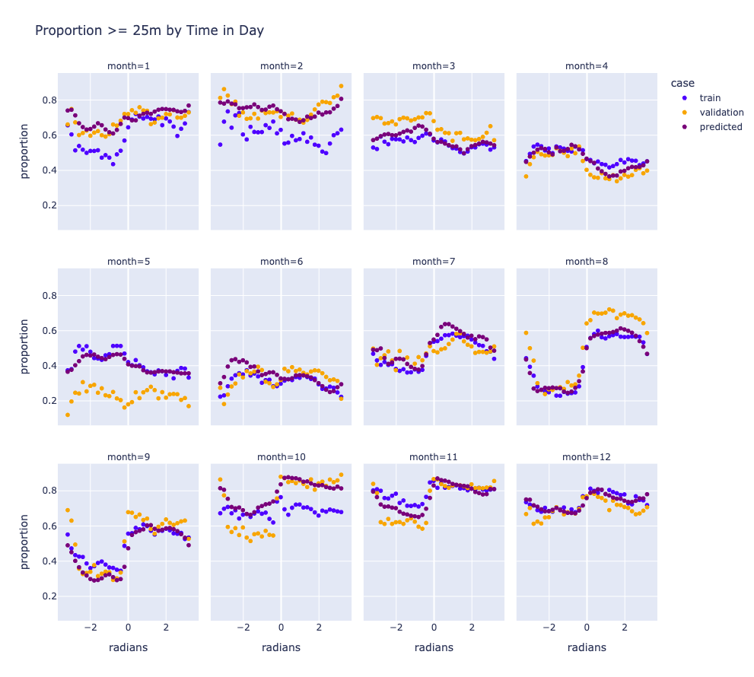
Figure 2: Diel Variation Using observations taken at 15-minute intervals from Chinook salmon in the GOA and EBS, the proportions of samples deeper than 25m as a function of time of day across all months. Validation is the proportion over the validation data, train is the proportion over the training data, and predicted is the mean predicted probability of the occupied depth over the validation data.
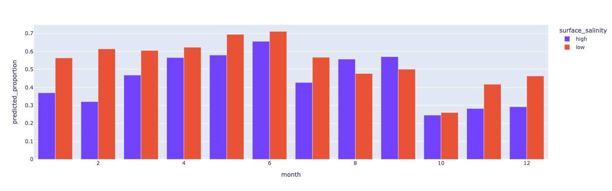
Figure 3: Effect of Salinity Using predictions of depth occupancy at 15-minute intervals for Chinook salmon using a deep learning model, predicted proportions of fish within 25m of the surface when surface salinity is above (high) and below (low) 31.3ppt. Predictions were made over the validation dataset.
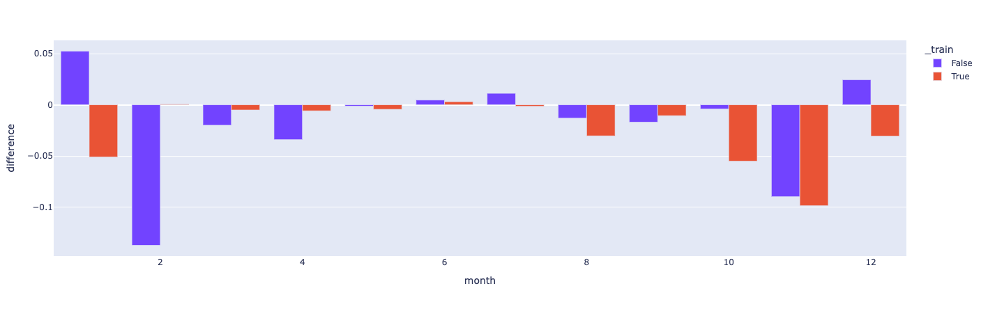
Figure 4: Variation in Performance of Salinity as a Feature Change in loss across months when adding salinity as a feature to a deep learning model of Chinook salmon depth occupancy. Red indicates the training dataset whereas blue indicates the validation dataset.

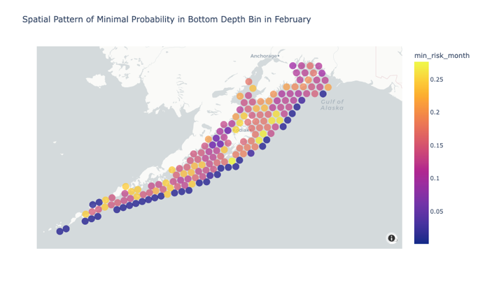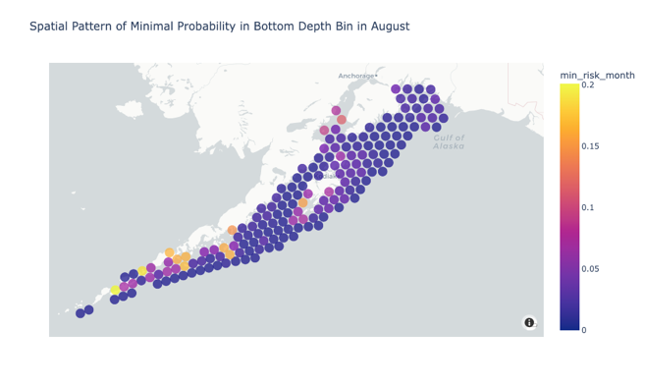
Figure 5: Spatial Distribution of Minimum Likelihood. Minimum likelihood of Chinook salmon occupancy in the deepest bin over each hour in the months of February (left) and August (right) as predicted by our deep learning model. 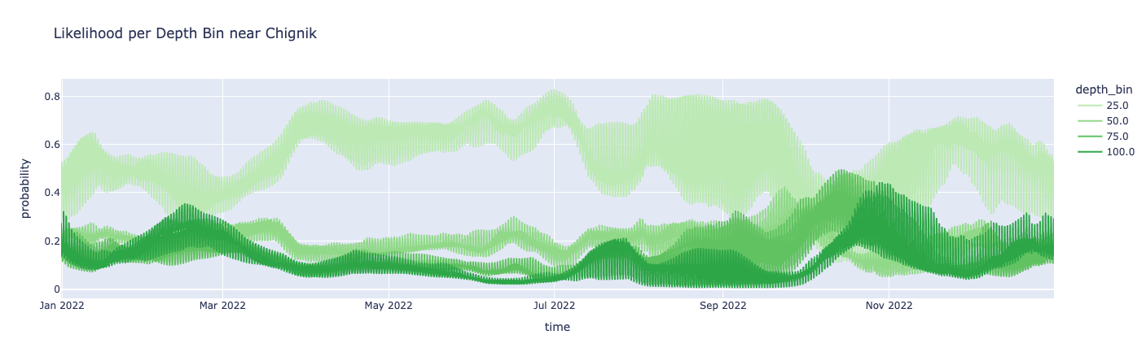
Figure 6: Full Year of Likelihoods Predicted likelihood, using our selected model, of occupancy per depth bin for Chinook salmon across all hours in 2022 for an H3 cell near Chignik, AK.
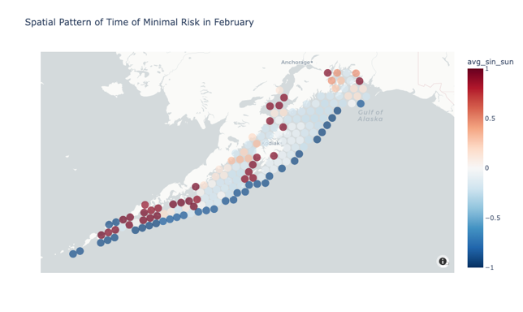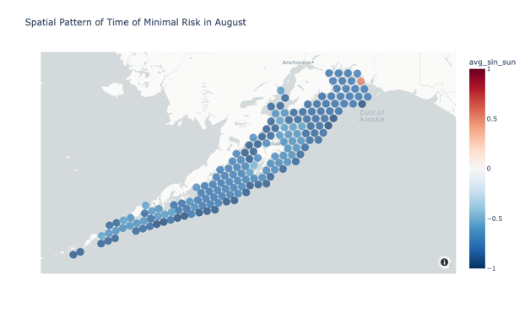
Figure 7: Time of Day Minimization. Time of day when the predicted likelihood, from our selected model, in the deepest bin for Chinook salmon is minimized on February (left) and August (right) 15. Negative values indicate nighttime whereas positive values indicate daytime.

